The 18 instructions shows in the sequence according to that 18 instructions in the process pdf.

1. Functioinal:

First 9 insts:

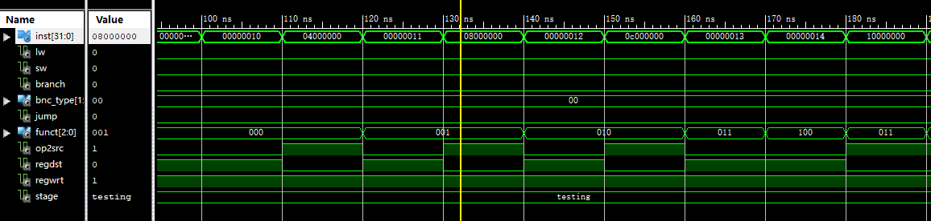

Last 9 insts:

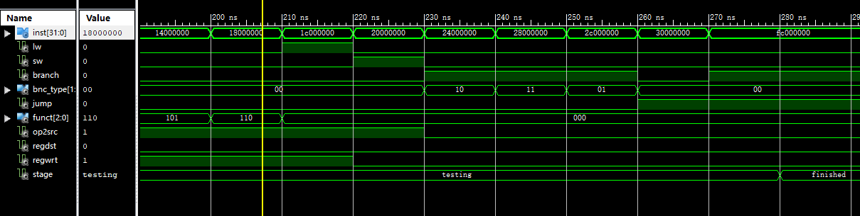

In all :

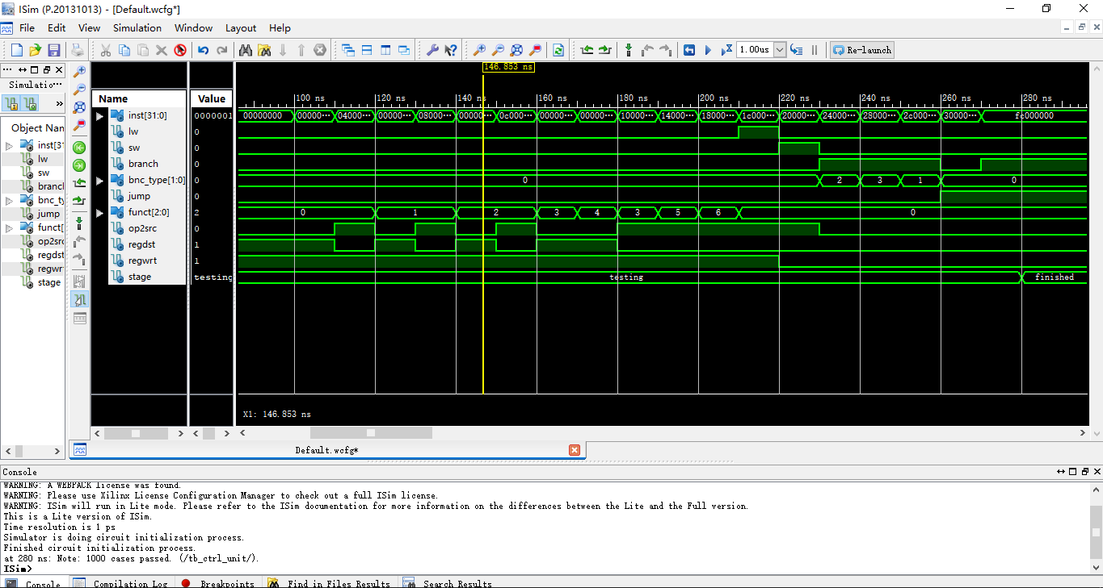

1. Timing:

First 9:

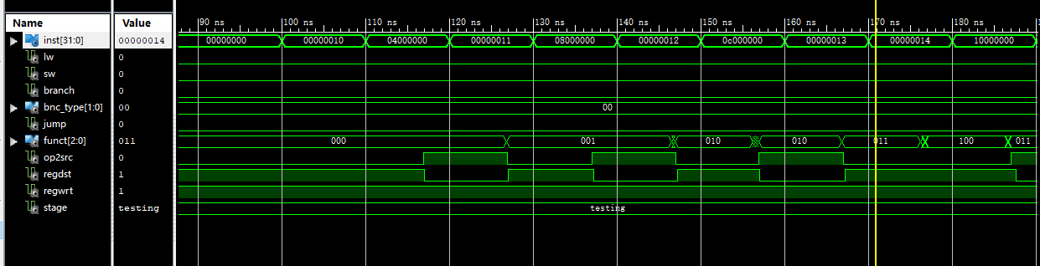

Last 9:

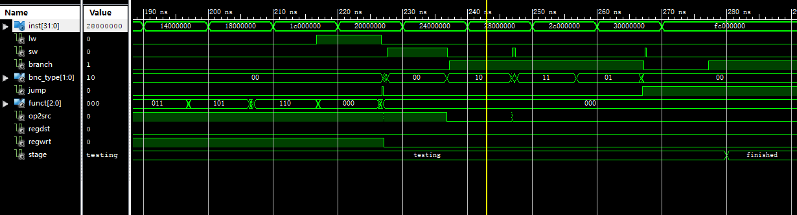

In all:

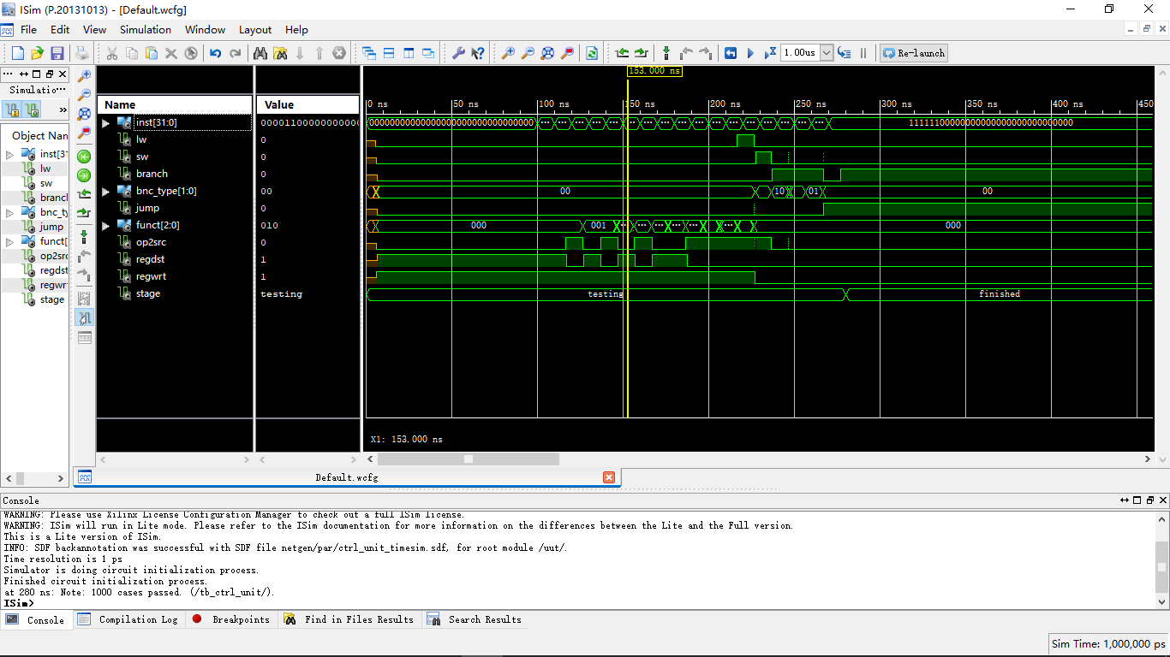

1. Delay：

180,000.000 ns to run 18,000 instructions, 10ns for 1 input which is the wait period in test bench code. I can see no delay here. Wired…

1. RC5:

ukey = 0x00000000000000000000000000000000

A_in = 0x00000000

B_in = 0x00000000

A_enc = eedba521

B_enc = 6d8f4b15

